# Windows Server 2016 Technical Preview 5 - Guest Clustering Installation & Configuration using Shared Virtual Hard Disk (.vhds - New Feature) & Expanding Shared VHD Online

Guest Clustering is used for any web hosting web applications or any files share configurations to provide high availability on application level in case if any VM goes down due to any reason, still application service will be up and running from another Virtual machine.  
  
To see Windows Server 2016 Technical Preview 5 Overview, [**Click Here!**](http://www.mdtechskillssolutions.com/2016/09/windows-server-2016-technical-preview-5.html)  
  
To see Windows Server 2016 Technical Preview 5 Hyper-V Installation, VM Deployment & What's New in VM Settings, [**Click Here!**](http://www.mdtechskillssolutions.com/2016/09/windows-server-2016-technical-preview-5_24.htm)

To see Windows Server 2016 Technical Preview 5 Failover Clustering Installation, Configuration & Post Configurations Process, [**Click Here!**](http://www.mdtechskillssolutions.com/2016/09/windows-server-2016-technical-preview-5_25.html)  
  
Let's start by understanding concept & use of guest clustering...  
  
What is Guest Clustering?

Guest Clustering means configuring Failover Cluster feature between Virtual Machines. Concept is same as of physical clustering except it uses Virtual Hard Disk instead of physical disk.   
  
We can use physical disk as well to configure clustering via virtual fibre channel but in that case VMs can not be live migrated from one node to another.   
For configuring high availability on application layer like any web site or SQL always-on, we configure clustering on virtualisation level.

## Prerequisites for Guest Clustering:

Prerequisites for Guest Clustering is similar to physical server clustering still I will explain the process to follow because concept for creating Guest Clustering on Hyper-V Host with Win Server 2016 is changed as compare to Win 2012 R2 or older version.   
  
Follow below points to create Guest Clustering on Host with Windows Server 2016:

* Create 2 Virtual Machines with OS: Win 2012 or Win 2012 R2 or Win 2016 TP5.
* Configure Network.
* Turn OFF Firewall
* Join virtual machines to Domain.
* **Create shared virtual disk (.vhds) - NEW in WIN Server 2016. (1 Disk for Quorum & 1 Disk for CSV)**
* Add both disk to Virtual Machines as **Shared Disk - NEW option.**
* **Online & Create simple volume for Quorum Disk with DRIVE NAME & LETTER.**
* **Online & Create simple volume for other disk WITHOUT Drive Name & Letter.**
* Install Failover Cluster feature on both machines.

## VHD SHARE OPTION Changes in WIN Server 2016 TP5 as compared to Win Server 2012 R2:

### *In 2012 R2:*

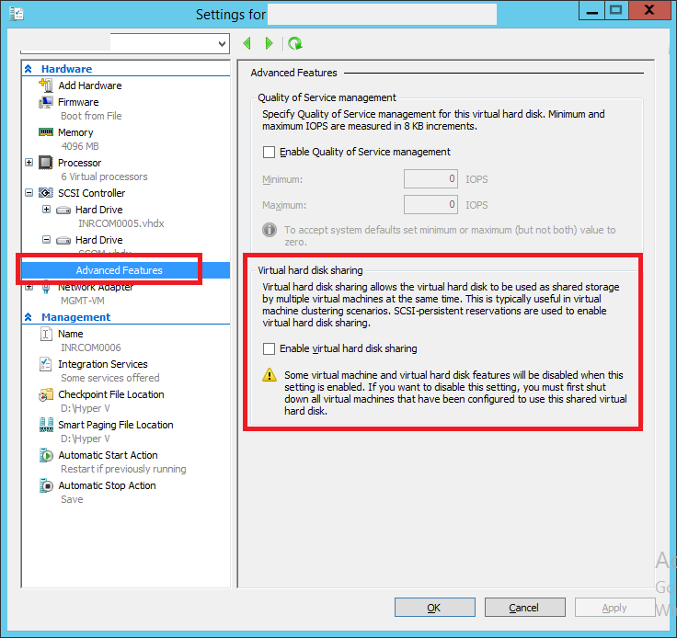

### *In 2016:*

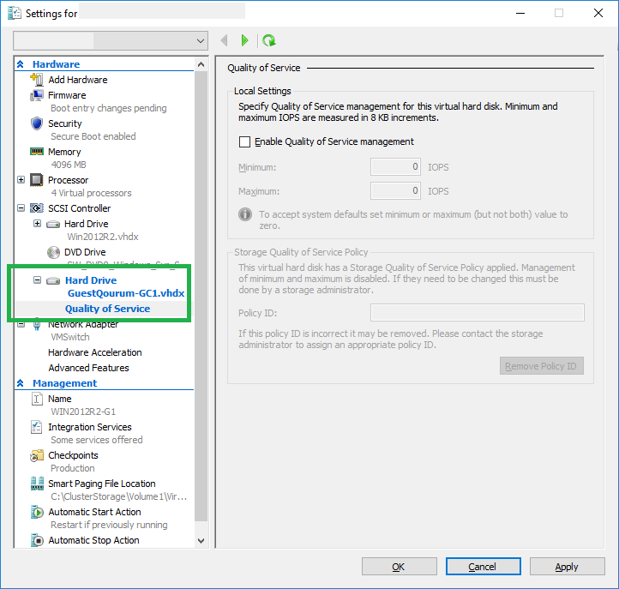

## Create Shared Virtual Hard Disk in Win Server 2016 TP5:

Open Hyper-V, Click on New in Action Pane & then click on Hard Disk:

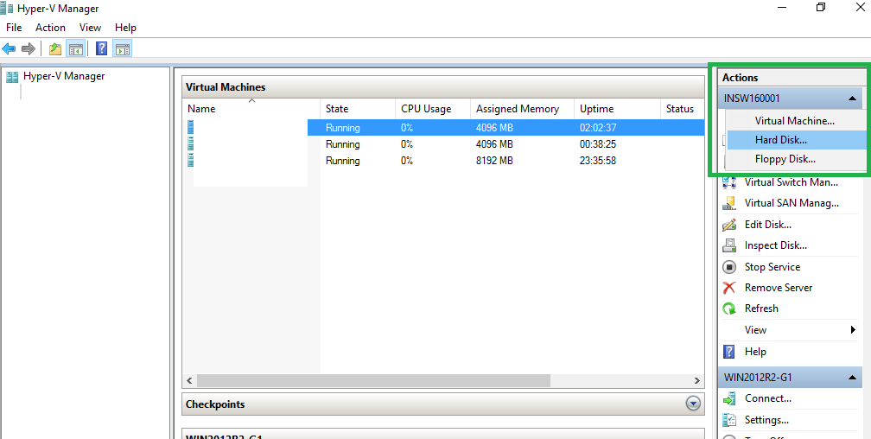

Click Next:

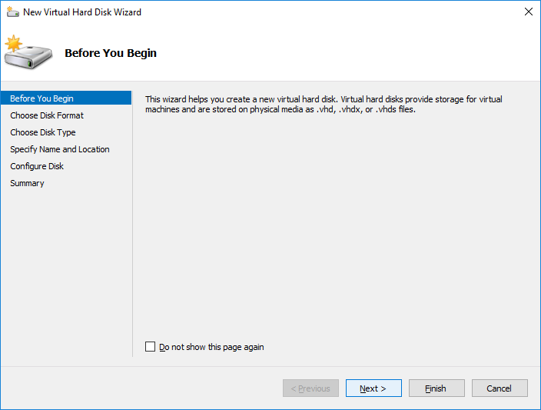

Select VHD Set (New) & Click Next:

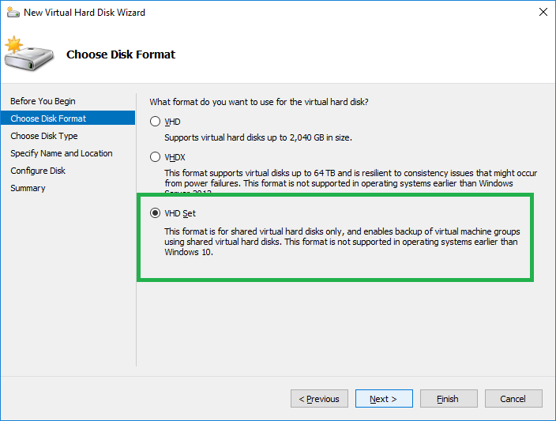

Select Disk Type & Click Next:

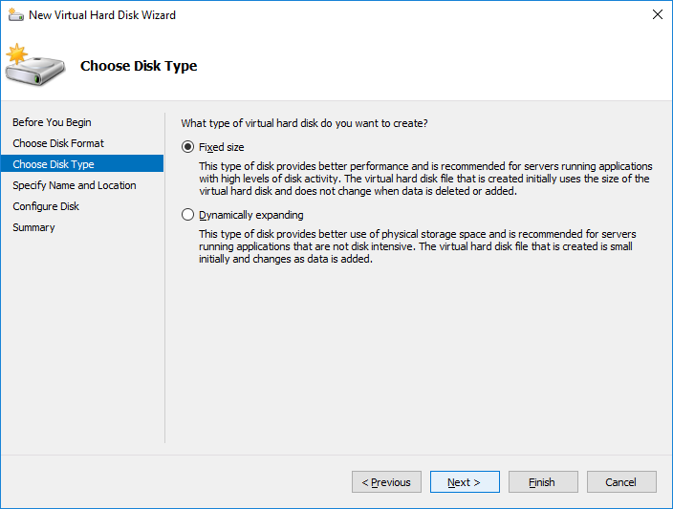

Give Name, Path & Click Next:

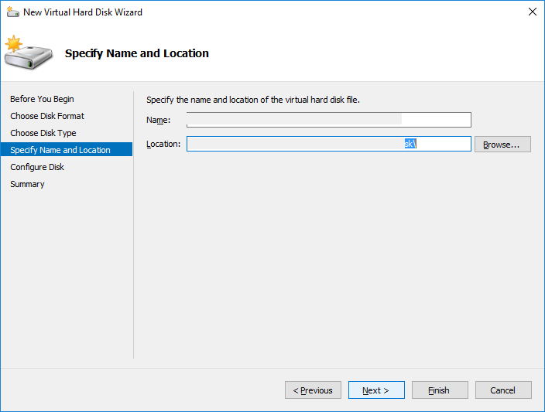

Define Disk size & Click Next:

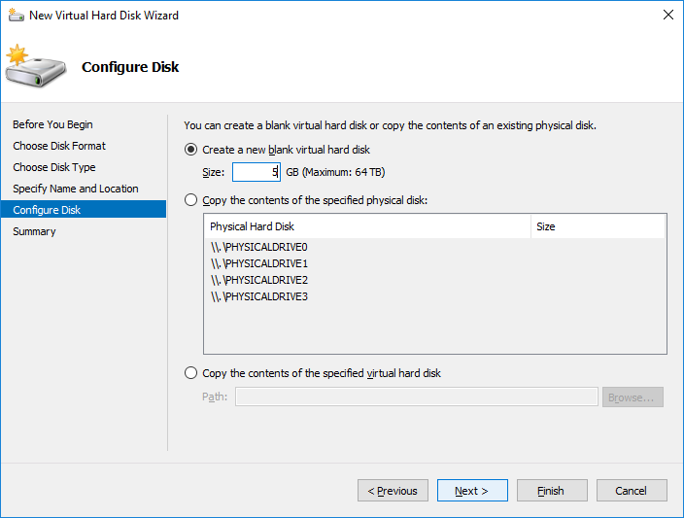

Click Finish:

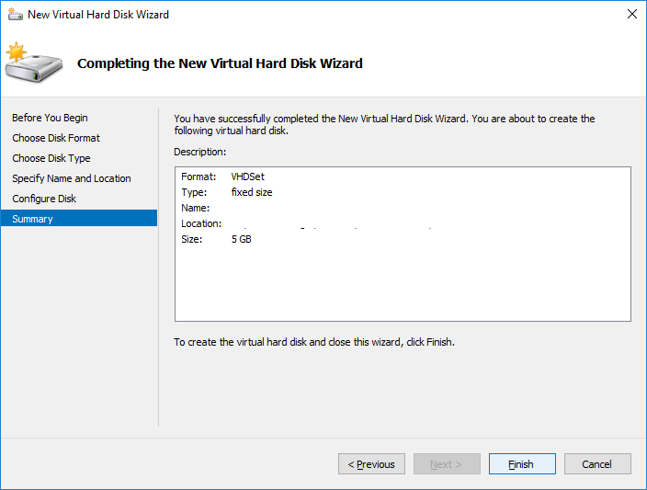

Create another disk using same steps as above mentioned which will be added to Guest Cluster as CSV Volume. Later I will show online increasing for CSV volume which is new feature of Windows Server 2016.

## Add Disk to Virtual Machines:

Add above created shared disk to virtual machines which will be used for Guest Clustering (You can add disk Online - while VMs are running).  
  
Right Click on VM & Click on Settings:

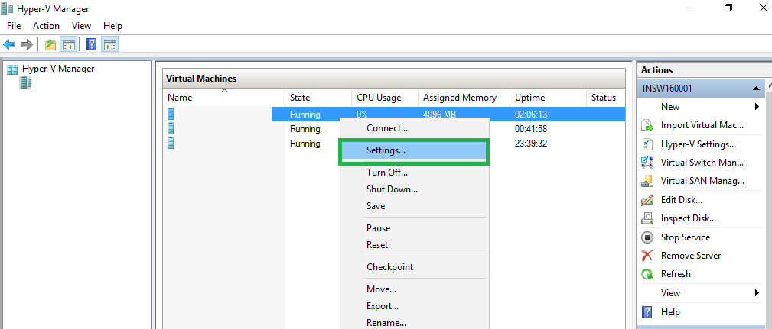

Click on SCSI Controller, Select Shared Drive & then Click ADD:

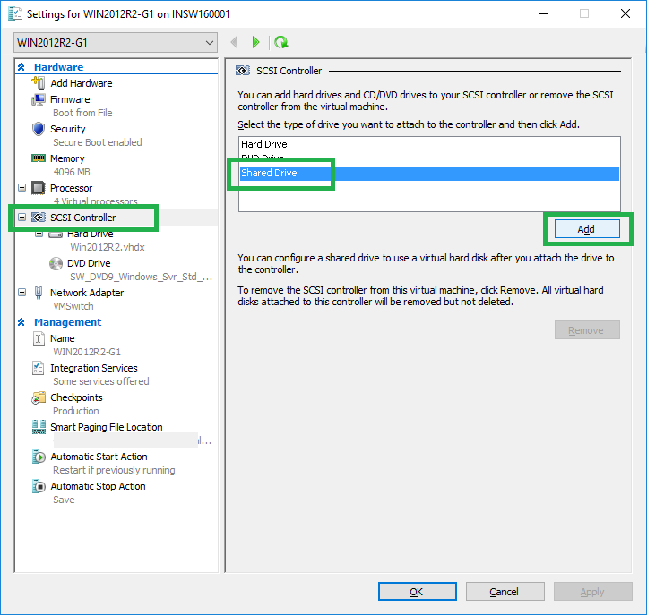

Click on Browse, Select Disk from folder where You saved the disk & Click Apply, OK:

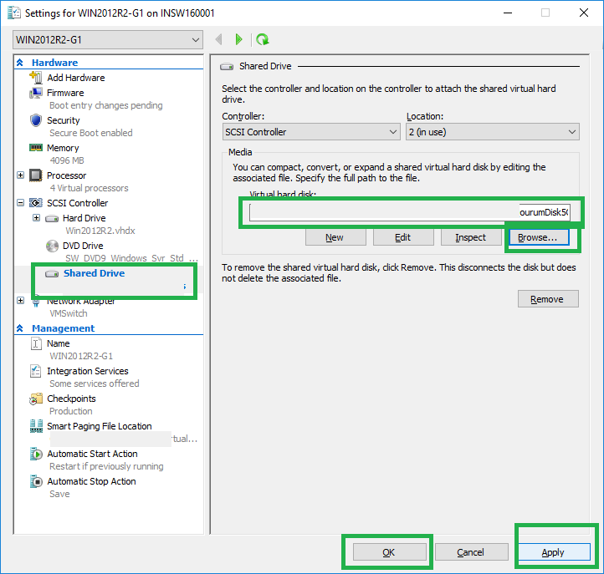

Repeat same step for all VMs which You will be using for Guest clustering. Same shared disks will be adding to all VMs.  
  
Once done above steps, connect to VM, Open Disk management:

* Online, Initialize & Create Simple Volume with Drive Name & Drive Letter for Quorum Disk from any 1 Virtual Machine.
* Online, Initialize & Create Simple Volume without Drive Name & Drive Letter for other Disks which will used as CSV Volume from any 1 Virtual Machine.

NOTE: When You online disk from 1 Virtual Machine then It will be shown as reserved on other virtual machines with Blue Color on disk:

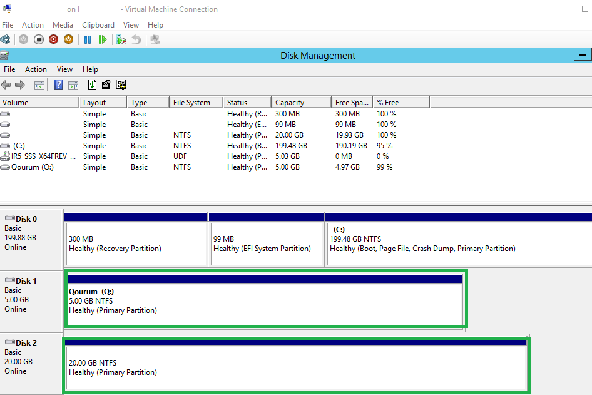

## Failover Cluster feature installation on Virtual Machines:

Once all prerequisites are ready then start the Failover feature installation & configuration in Virtual Machines.   
  
All steps are same as done on physical server ([**Shown in previous post. To see previous post, Click Here!**](http://www.mdtechskillssolutions.com/2016/09/windows-server-2016-technical-preview-5_25.html))  
  
Once Installation completed then You can see Failover Cluster console on VM as shown below:

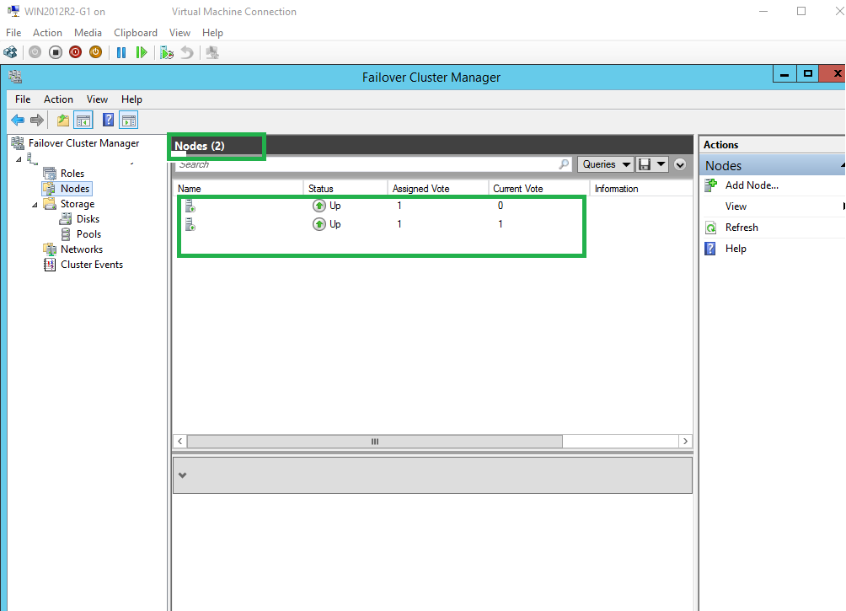

### Add Disks to Guest Cluster:

Expand Storage, Click on Disk & then Click on Add Disk in Action Pane:

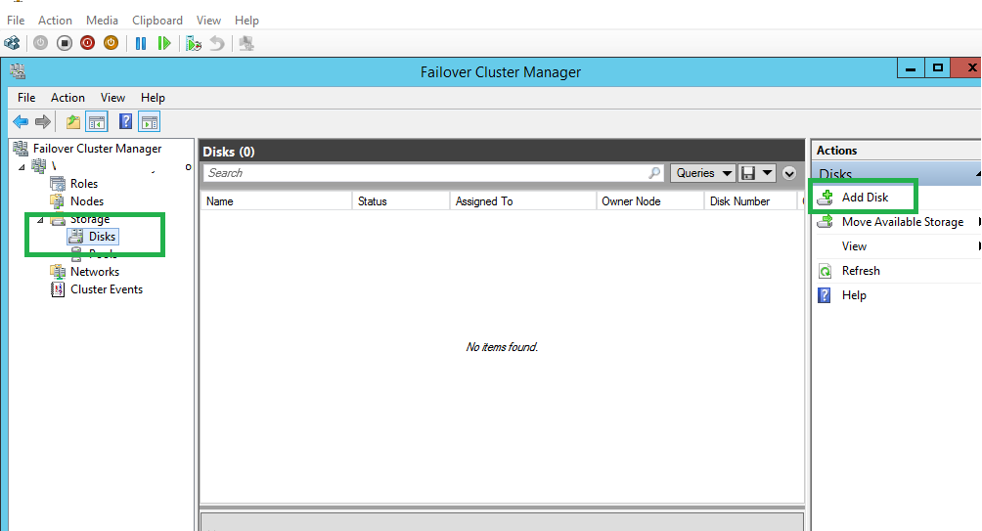

Select Disk and Click OK:

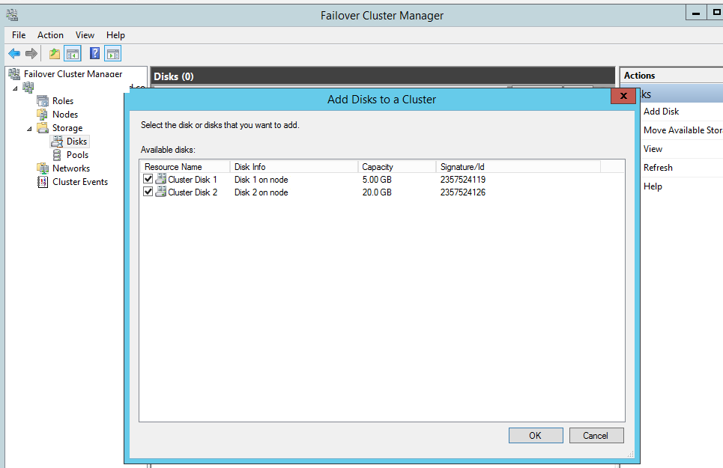

Right click on Disk which You want to add as CSV Volume & Click on Add to Cluster Shared Volume:

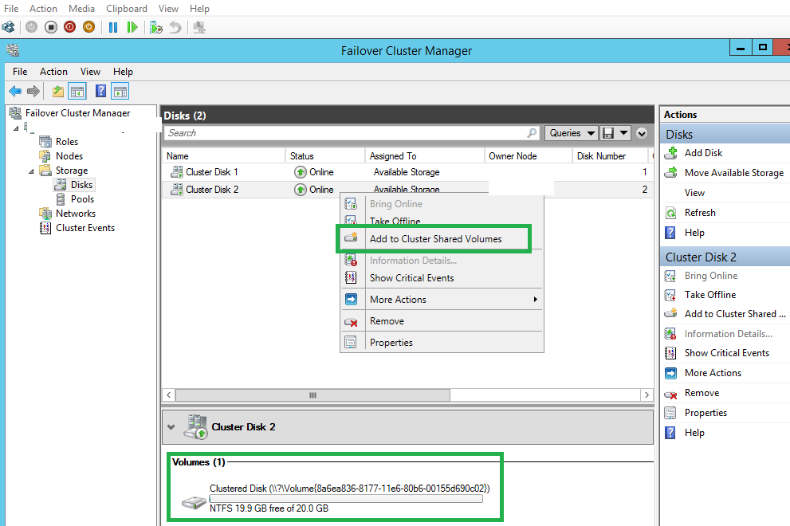

Successfully added as CSV:

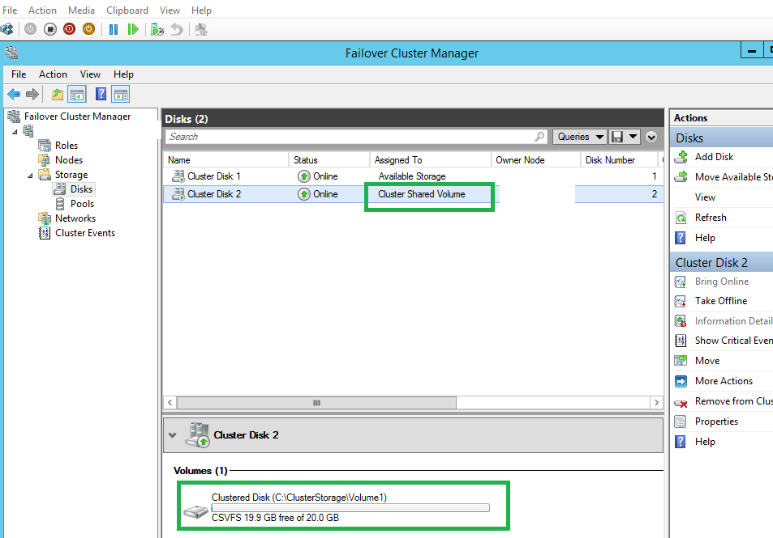

### Configure Cluster Quorum:

[**Click here to know about Quorum in Windows Cluster!**](https://technet.microsoft.com/en-us/library/cc731739(v=ws.11).aspx)  
  
  
  
Right Click on Cluster Name, Click on More Action & then Click on Configure Cluster Quorum Settings:

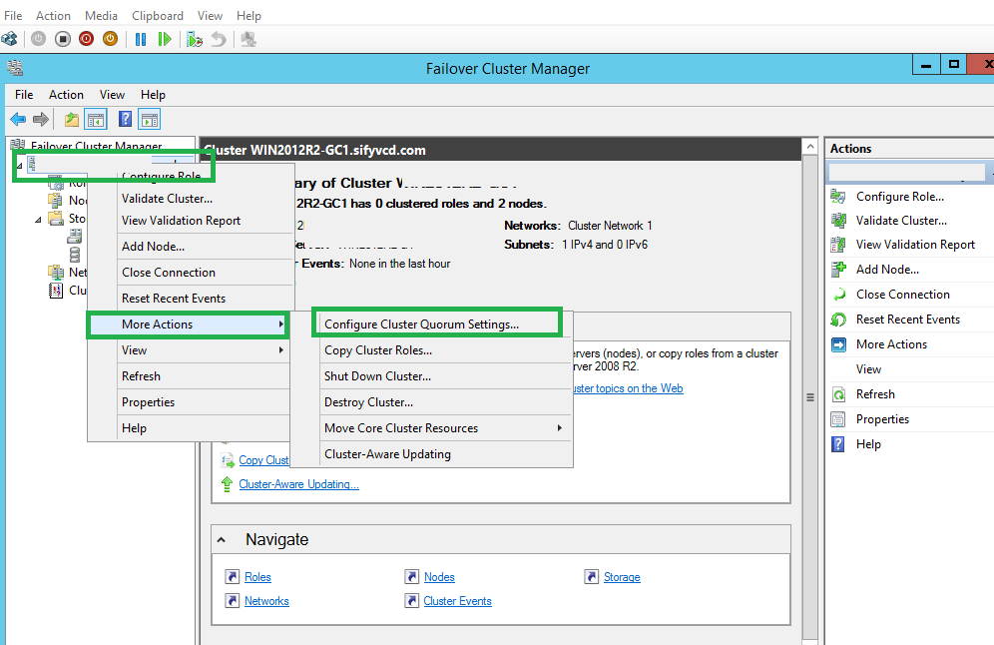

Click Next:

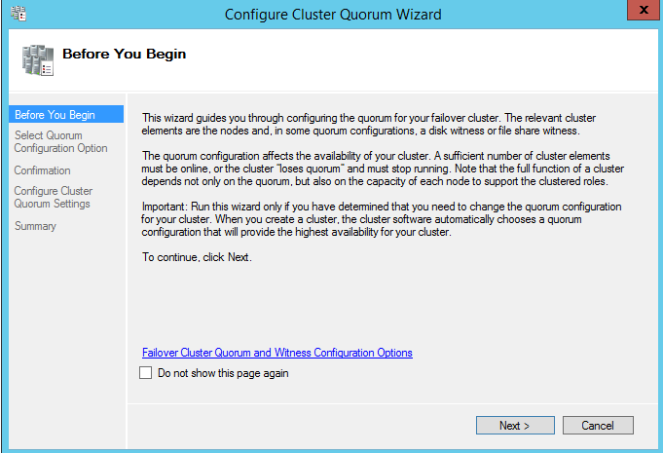

Select Advance Quorum Configuration to configure Disk Witness Quorum & Click Next:

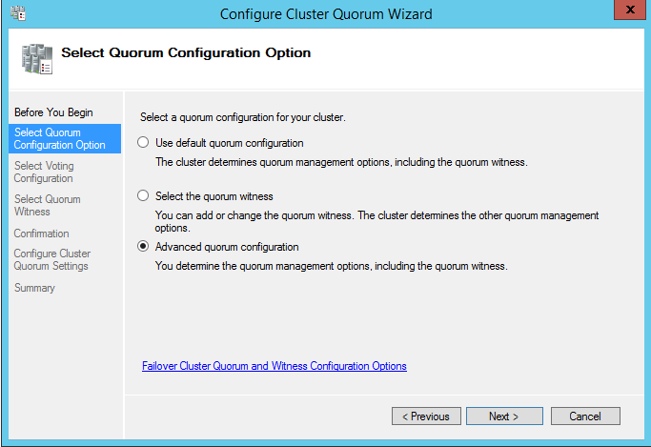

Click Next:

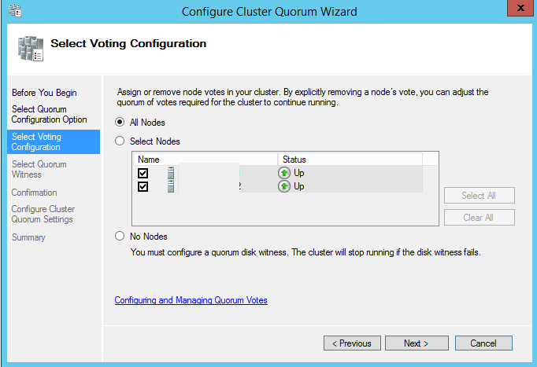

Select Configure a disk witness option & click Next:

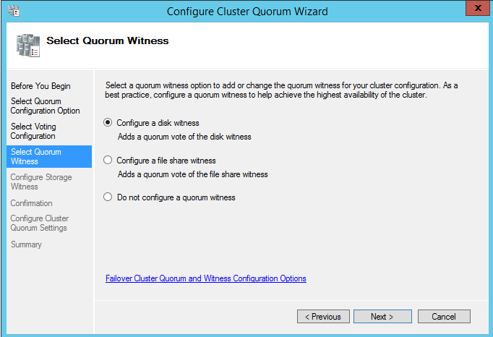

Select only disk which You want to configure for Disk Witness Quorum (Max. 5 GB size is enough) & Click Next:

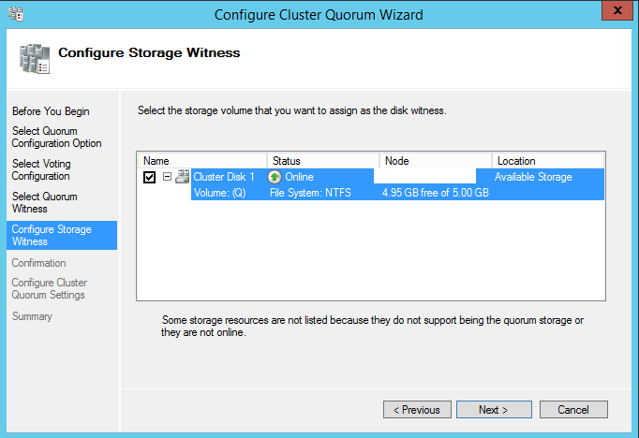

Click Next:

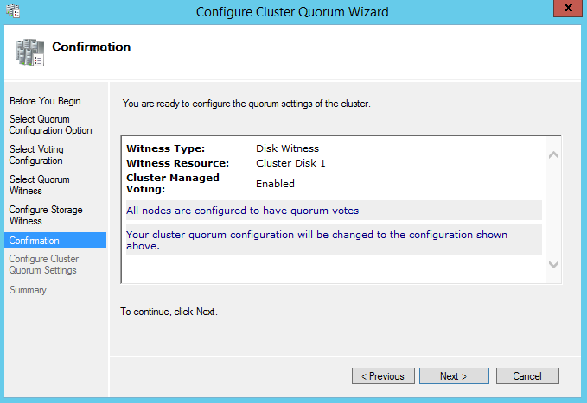

Click Finish once done:

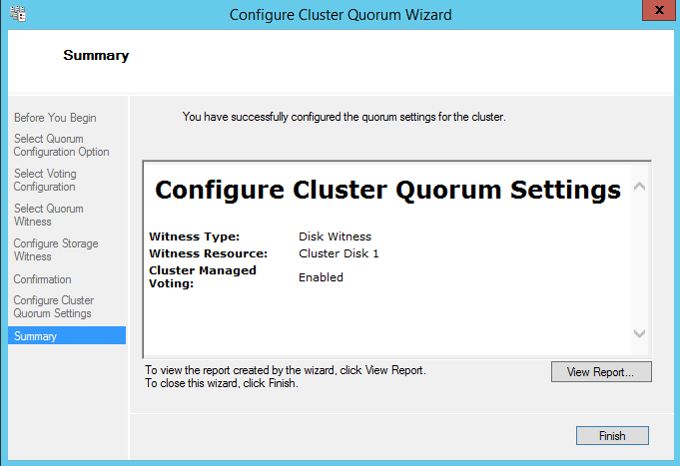

Disk is changed to "Disk Witness in Quorum" in Cluster Console:

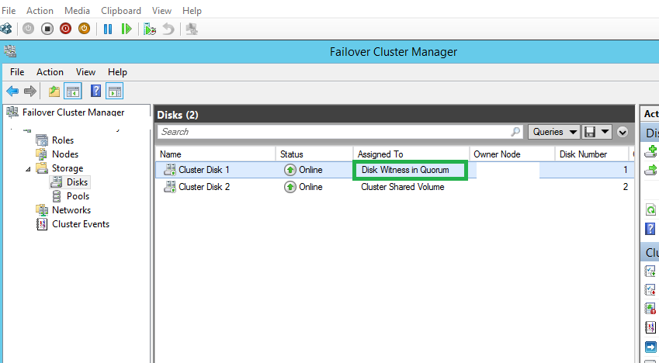

All done now.

## Testing expanding Shared Virtual Hard Disk Online (New Feature):

Click on Edit Disk in action pane (VMs are running):

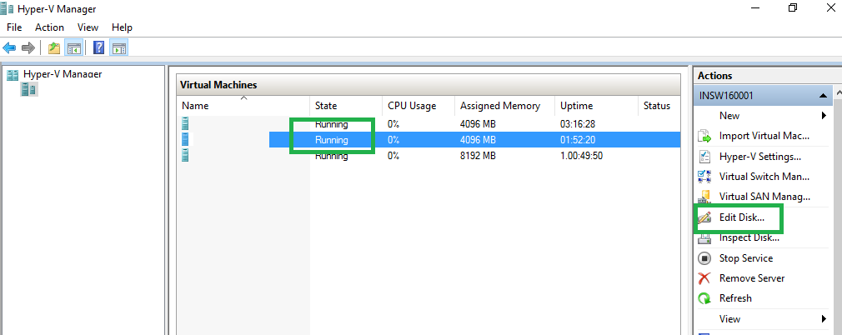

Click Next:

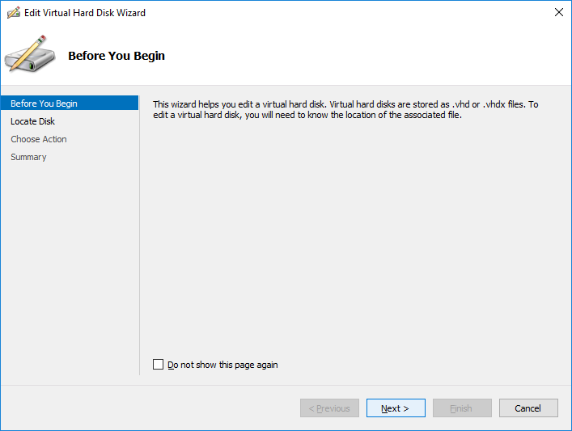

Select the Shared Disk which is added as CSV Volume in Guest Cluster above & Click Next:

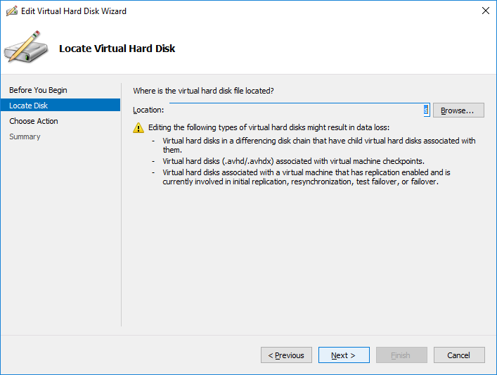

Click Next:

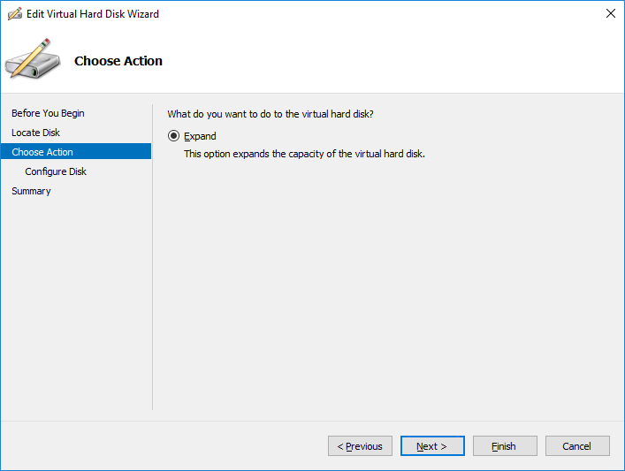

Give new size and Click Next:

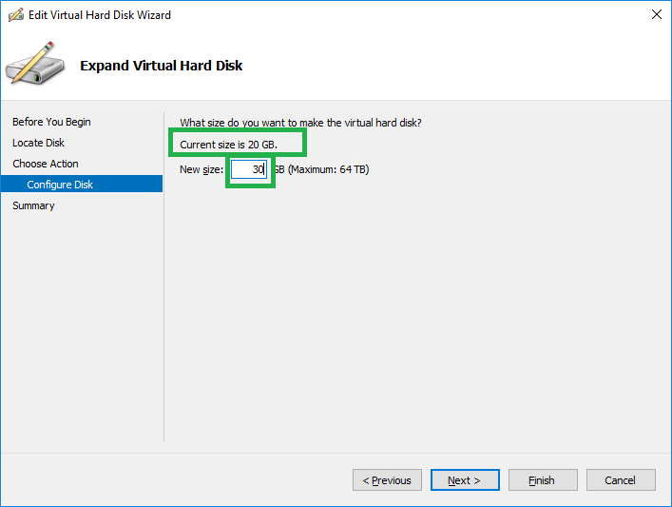

Click Finish:

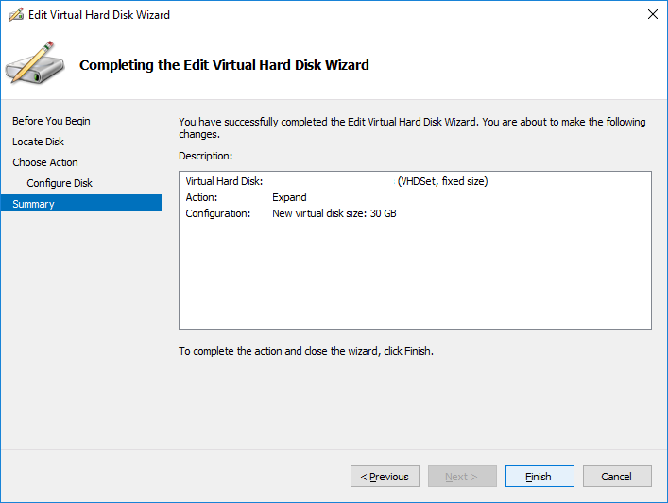

Connect to any Clustered VM, Open Disk Management & You can see that additional disk space is added successfully without any down-time:

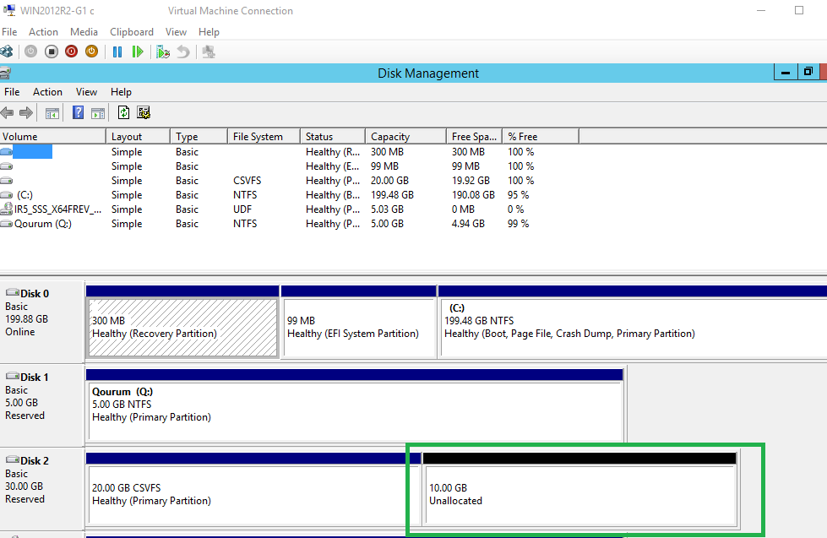

Once You shrink volume, same will be updated in cluster console as well:

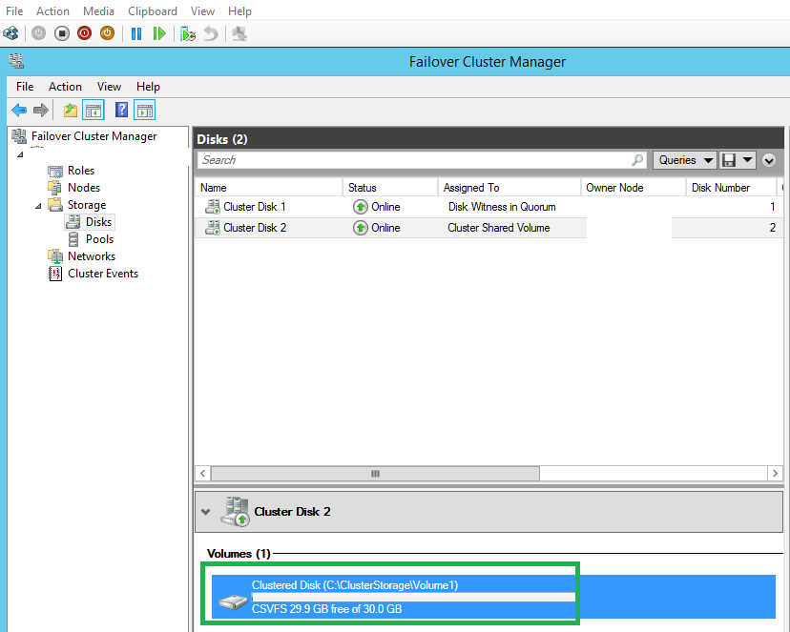

**This is all about Guest Clustering & expanding shared VHD without down-time (new feature).**

**Thanks,**

**Mayank Dhama**

**Happy to Help ☺**

You can join my Facebook group for updates on trending technologies/technical references/issues etc:

<https://www.facebook.com/groups/technicalskillsenhancementworld/>

Visit My Blog Site:

<http://www.mdtechskillssolutions.com/>

Technet Profile:

<https://social.technet.microsoft.com/profile/mayank%20dhama/>